Business Cycle / theory of economic development (J.A. Schumpeter)
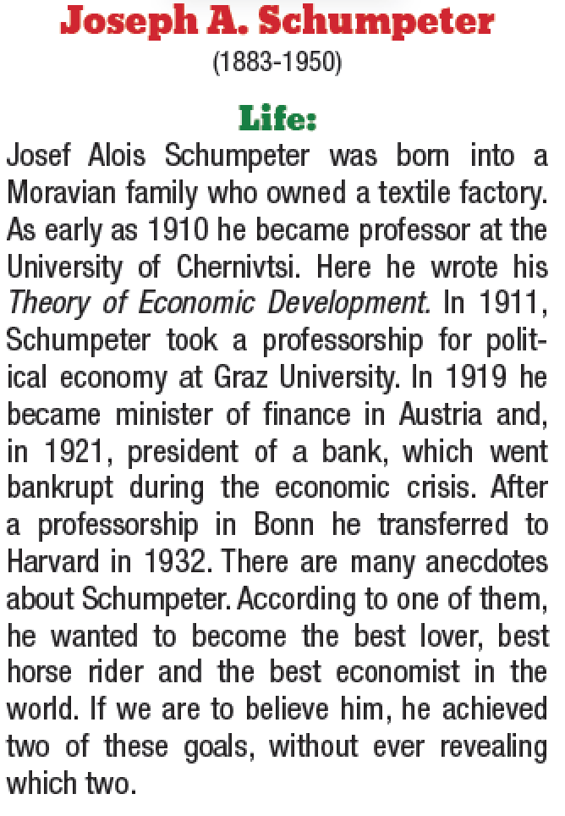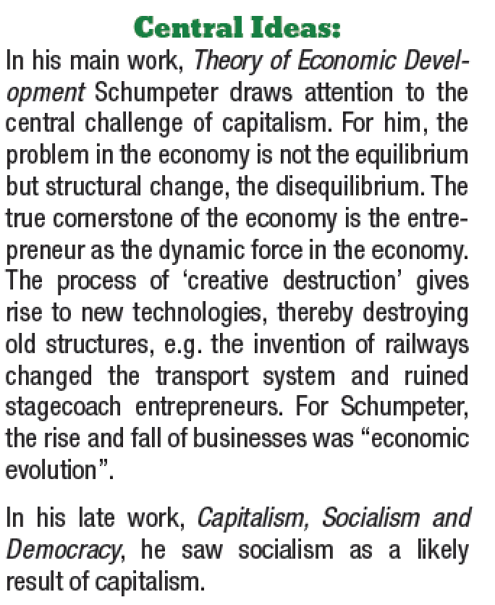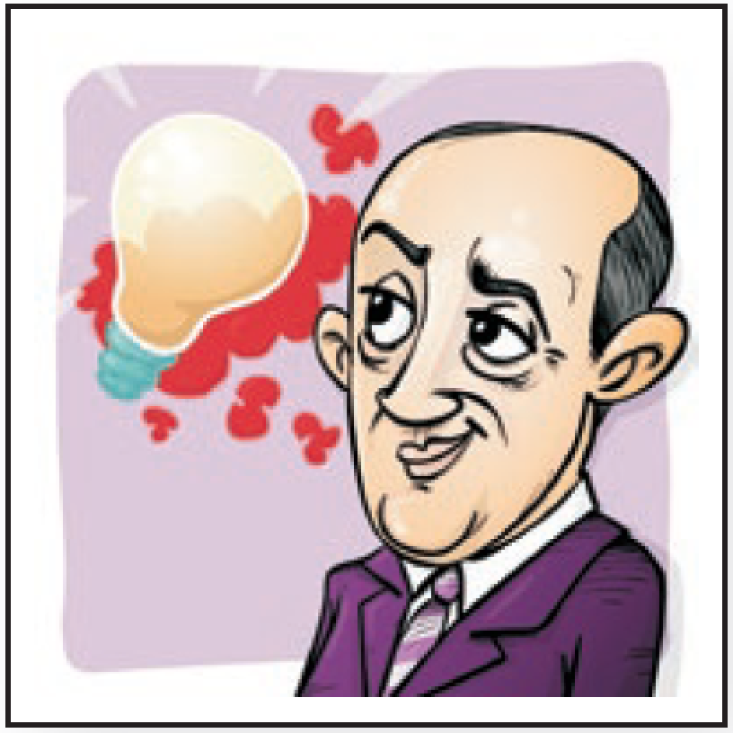

Business Cycle
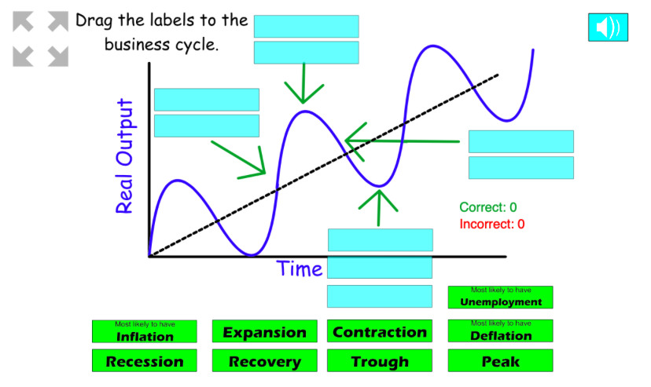

Characteristics oft he individual phases of a business cycle:

Characteristics | Expansion | Peak | Recession | Trough  Depression
General mood
Investments
Labor market, income
Consumption, prices
Capital market (loans), interest
Stock market

