Knowledge, background, calculations
Sources Calorie (lat. calor = heat) is a physical unit for energy, work and heat quantity. The term calorie is often used instead of kilocalorie. With 1 cal you can heat a gram of water by one degree Celsius, more precisely from 14.5 to 15.5 degrees. One kilocalorie is 1000 calories, i.e. it can heat 1000 g of water, or 1 litre, by one degree.
Calorie consumption depends on the activity. The more "strenuous" the activity, the higher the calorie consumption. It can be converted into watt/h as well - to have a comparison to other ways of mobility:
No movement
- Lying down: 68 kcal/h → 0,079084 watt
- Sitting with leaning: 71 kcal/h → 0,08 watt
- Sitting without leaning: 72 kcal/h → 0,08 watt
- Standing, relaxed: 75 kcal/h → 0,08 watt
- Standing, firm: 78 kcal/h → 0,09 watt
Movement
- Walking, level at about 3.6 km/h: 210 kcal/h → 0,24 watt
- Walking, level at about 6 km/h: 350 kcal/h → 0,4 watt
- Climbing steps at 10 steps in 10 seconds: 360 kcal/h → 0,36 watt
- Cycling, about 15 km/h: 380 kcal/h → 0,5 watt
- Swimming: 640 kcal/h → 0,7 watt
- Jogging: 750 kcal/h → 0,9 watt
Read more at: https://www.lebensmittellexikon.de/k0000940.php
For calculation and to get a feeling and a measure of energy consumption while mounting stairs:
- Mounting one stair needs 0.11 calories.
- To burn a single calorie, it takes ten steps upwards.
- Climbing stairs for an hour.
  - Set your pace so that you climb 10 steps at a time in 10 seconds → 1 calorie → 0,001 watt
  - You will burn around 6 calories in 1 minute → 0,006 watt
  - You will burn around 360 calories in 1 hour. → 0,36 watt
Imagine you were super fit and could do this physical feat for 10 hours. And imagine you didn't need any breaks and didn't eat anything during that time. Then you would have used 3,6 watts of energy. That's how much a small LED lamp needs to light up for 1 hour. And the LED lamp is already extremely energy-saving! But you will be rather exhausted after this time…
Here is a calculator, to convert calories into Energie (watt):
Convert calories per hour to watt - Conversion of Measurement Units (convertunits.com)

Instruction
- Do a self-test: Mount 10 steps (in your school-house or outdoors)
- found the pace of mounting 10 steps in 10 seconds
- Repeat it for some minutes - how many you are happy with and time allows it!
- Calculate your calorie - and energy-consumption according to the information above.
- Compare: traveling a 5 kilometer distance with different vehicles
Which form of transport has the smallest carbon footprint? - Our World in Data

Worksheet/instruction

Photostory
Make a photo-story from people moving around your school: on foot, by bike, by car, by public transport, by train. Combine it with a short survey - asking them:
- why they use this way to go around
- what distances they need to bridge
- what purpose they use the mode of moving
- if they know about the carbon-footprint per Kilometer
Mind that you do not show faces, if you did not ask to publish the foto! If you like, use this frame and proposal for your foto-story. Use the diagram to tell the people you ask about the carbon footprint:
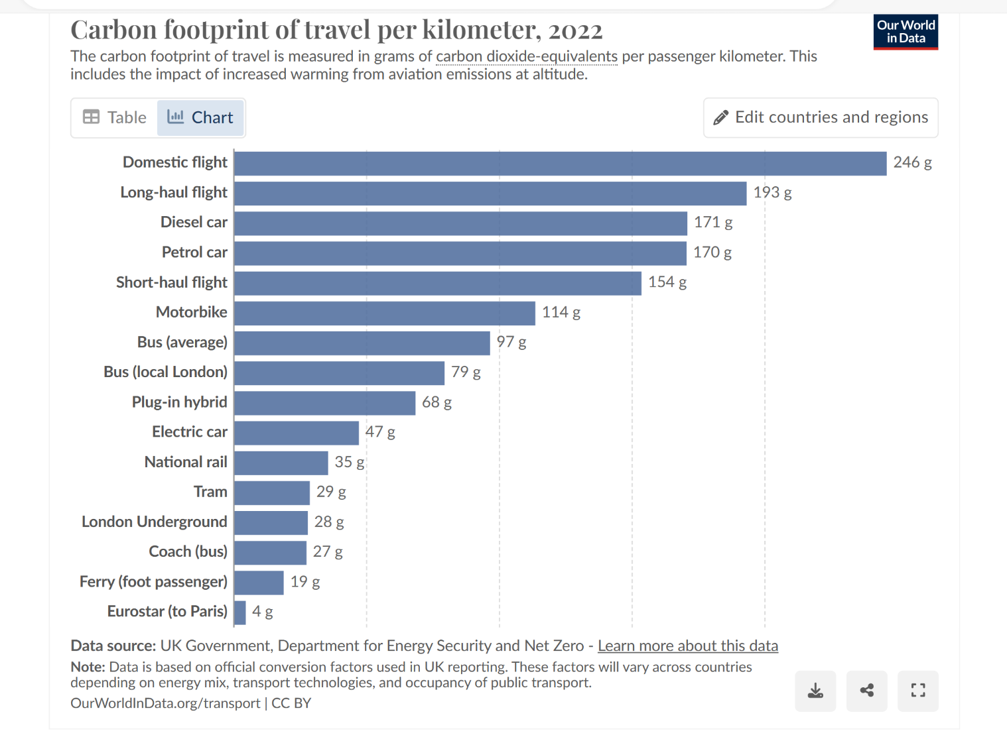

Background-Information: Walk, bike or take the train for the lowest footprint
Over short to medium distances, walking or cycling are nearly always the lowest carbon way to travel. While they’re not in the chart, the carbon footprint of cycling one kilometer is usually in the range of 16 to 50 grams CO2eq per km depending on how efficiently you cycle and what you eat. Using a bike instead of a car for short trips would reduce your travel emissions by around 75%.
If you can’t walk or cycle, then public transport is usually your best option. Trains are particularly low-carbon ways to travel. Taking a train instead of a car for medium-length distances would cut your emissions by around 80%.Using a train instead of a domestic flight would reduce your emissions by around 86%.
In fact, if you If you took the Eurostar in France instead of a short-haul flight, you’d cut your journey’s footprint by around 97%.
Which form of transport has the smallest carbon footprint? - Our World in Data

Vehicle/movement  picture | emotion, association, impression (personal) | distance | headline/subline | C02-Emission/kilometer
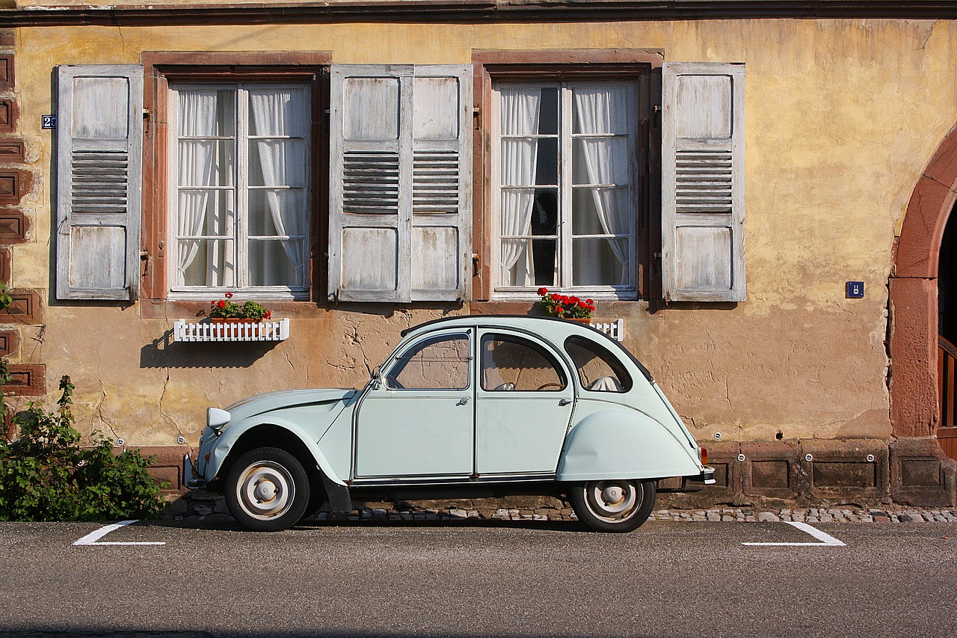 | cosy, warm, dry if there is rain, comfortable… | used for shopping food -between 2 and 30 km | more than half of the inhabitants in our village use the car for shopping | 170 g/km
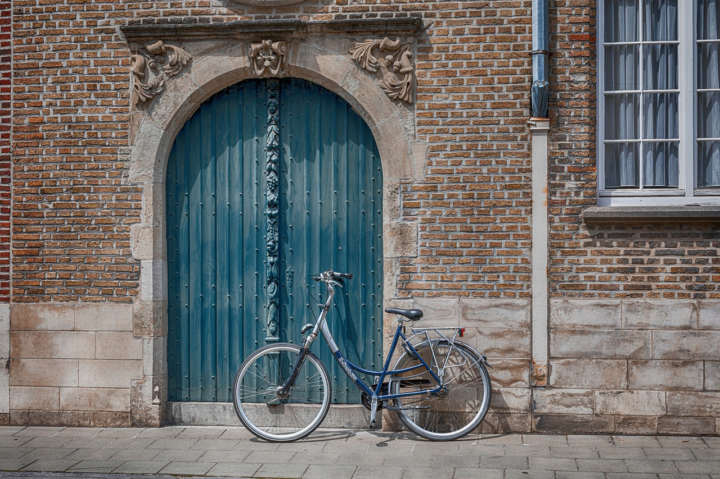 | fast, no parking-problems, cheap, possible for children, not always safe | 5 km | only 10 % of the population in our village use the bike to go around | 20 g/km
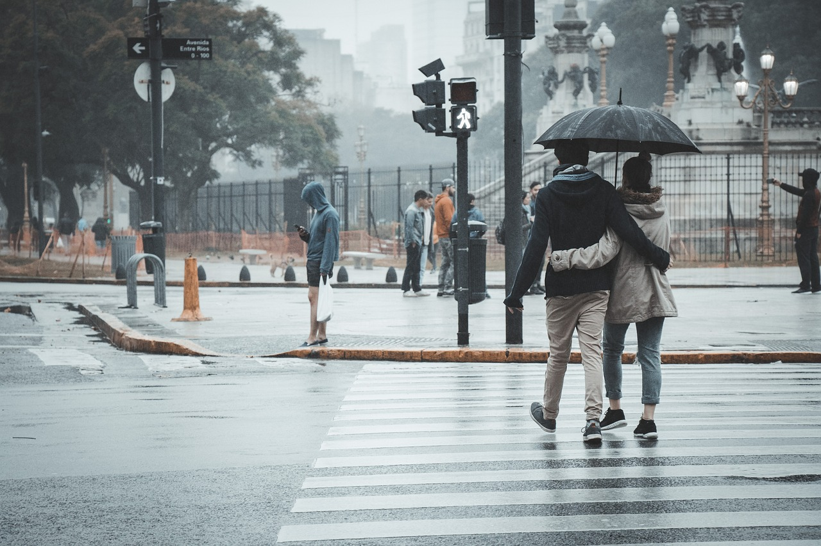 | slow, comfortable, bad to carry heavy load, wet in case of rain | 1-4 km | only few people walk within our village. There are 2 cars for each family - in average | 19/g/km
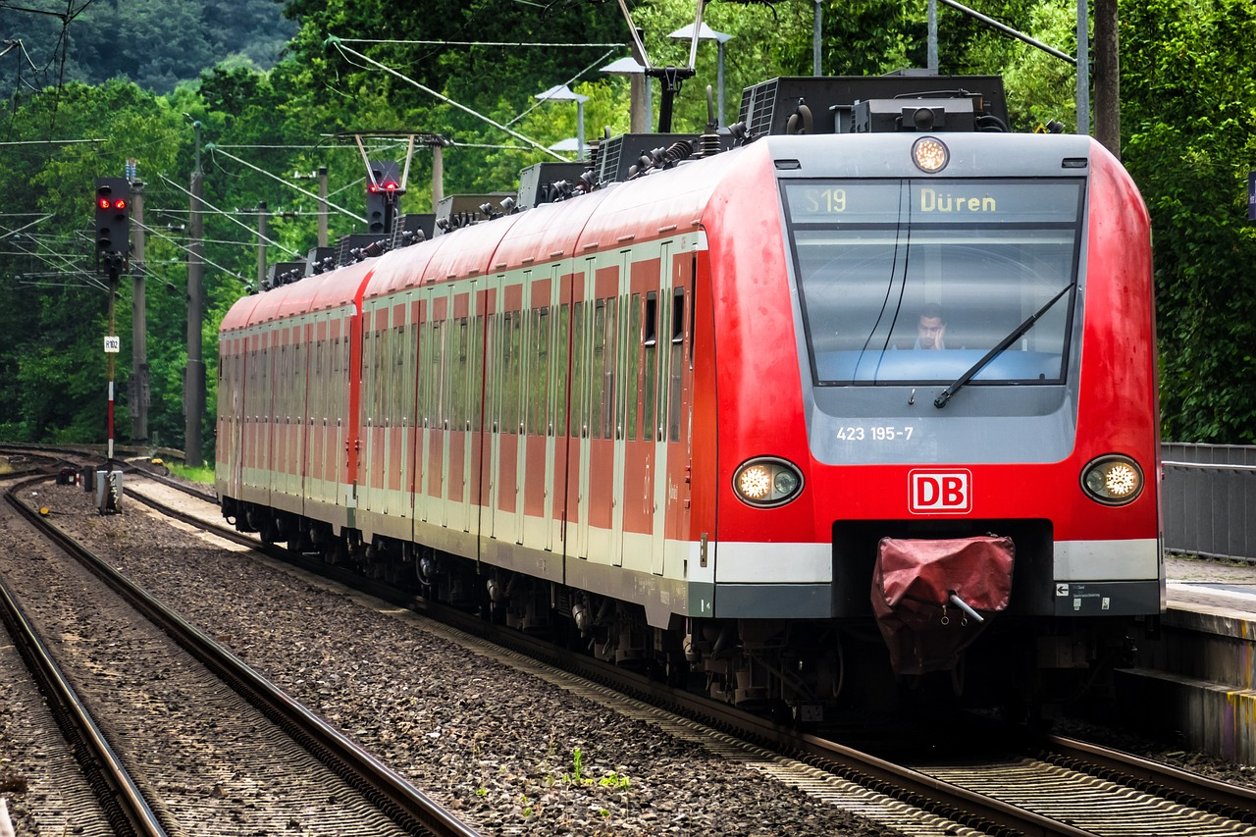 | fast, sometimes crowded, not cheap, not reliable | 10-60 km | 20 % of the people use the train to reach their place of work | 28 g/km

Deepening
Energy and fitness
Energy consumption for physical activities is often related to fitness - and also wellness. If you like, watch some videos to deepen your knowledge of the relationship between calorie demand and calorie expenditure during exercise.
- (3) How do you BURN CALORIES? 🔥 Energy explained. - YouTube
- (3) What is a calorie? - Emma Bryce - YouTube (TED)
- (3) How many calories does 10000 steps burn? - YouTube
- (3) Running Vs Cycling: What Burns The Most Calories? - YouTube

Knowledge: moving a heavy object
A medium-sized car weighs about one tonne (between 1,000 and 1,800 kg ). That means one car weighs about as much as 18 adults or 28 children. So it is most likely heavier than all of you put together. To move 1,000 to 1,800 kg, an engine needs a lot of petrol or diesel as fuel. When driving, the fuel is burnt. Energy is generated in the process and you can drive a car. This means that the stored energy in the fuel is converted into kinetic energy. This produces many exhaust gases, such as carbon dioxide (CO₂ ) or nitrogen oxides (NOx ), which pollute the environment. When a vehicle consumes one litre of petrol, it emits about 2.37 kilograms of CO ₂ . To drive 100 kilometres or 100,000 metres, a car needs about 7 litres of petrol. How much CO₂ does the car emit into the air when it drives the distance between your house and the school in km? But of course it also depends on how heavy the car is. Heavy cars consume more petrol or diesel for the same distance than lighter cars. But there are also alternatives to petrol and diesel, you've probably heard of them, it's about electric cars. For example, you can generate electricity with the help of wind energy and charge an electric car with this electricity and then drive it. This way you don't have to emit CO₂ into the air 😊
A lot of energy is needed to move a heavy object such as a car. A human being weighs little in contrast to a car. The box represents the car and the Playmobil figure symbolises a human being. When pulling, you feel that the extra "person" being pulled does not make a significant difference in the amount of energy needed. It is exactly the same in reality: the largest share of the energy that is needed is consumed by moving the car. The much smaller part of the energy is used to move people. That does not make much sense!
The journeys of all people in Europe caused more than half of the total CO2 emissions (60 %) of road traffic in 2019. Many people unfortunately also use the car for very short distances. However, starting the car and moving off unfortunately consumes a particularly large amount of fuel! Therefore, driving a car for short distances is particularly harmful to the climate.
Not only the exhaust gases that are produced when petrol or diesel is burnt are a problem! Many materials and raw materials are also needed for the production of fuels and cars. A lot of energy has to be expended before a car finally rolls off the assembly line in the factory. For the production of a single car, which weighs 1.5 tonnes on average, 70 tonnes of materials and raw materials are consumed.

Reflection activity
see “worksheet” - which is your foto-story about mobility-behaviour:
→ Summarise the results!

Action!
Set yourself a challenge and a motivation to reflect your mobility-behaviour
- Whenever you are tempted to drive your parents' car or they want to drive themselves, suggest cycling or walking as an alternative. Keep a diary for at least 1 month. Try to be honest with yourself and at the end count the kilometres you have travelled - without using the car.
- You may also want to motivate your family to go on a "green" holiday: Plan your holiday from a different point of view. Here are some videos that we find inspiring!
- There is also a programme called "Stadtradln" (Bavarian) in many cities in summer. Check if there are such initiatives in your city or municipality.
- Look for a cycling club or even communities that meet regularly for walking, hiking or jogging.
- If you feel, Freiburg as a model of a people-friendly, slow-mobility-town and your town/community is ages away from this: become political!
Ask for an appointment at the local council and whether or how you can put this issue on the agenda. All citizens of a city or municipality have the right to make proposals for discussion. Find out if there is a local politician who would support such a proposal and think together about how to get a majority for it - and of course money for its implementation. There are currently generous funding programmes in many European countries that aim to encourage a different mobility behaviour among the population.
- 35 SUSTAINABLE TRAVEL TIPS // easy, medium, and advanced - YouTube
- What's the greenest way to travel? - YouTube
- Sustainable travel - is it possible? - YouTube

