Instruction
- Position the halogen (or red-light) spotlight above the black and white paper-stencils. When there is sunlight outside, use the real sun! If you ask your teacher to laminate them, they can be used several times!
- Place an ice cube on each of the white and black laminated papers.
- Start a timer.
- Observe the effect of the "sun" (halogen/red-light-spot) on the ice cubes and write down your observations in the table below: After 2 minutes, after 4 minutes and after 6 minutes.
- Summarize your observations in an explanation.
- Then read the scientific explanation and try to understand it.

Worksheet: Your own observations

 | After 2 min. | After 4 min. | After 6 min.
Icecube or chocolate on white paper
Icecube or chocolate on dark paper

Deepening
Instead of ice cubes, use two pieces of butter and place the laminated white and black cards diagonally and put the butter on top and watch carefully what happens. Compare the melting of the chocolate with the melting of the ice-cubes. Discuss and research: Have you ever experienced a similar effect somewhere?

Reflection activity
The effect, you watch as the ice-cubes or the chocolate is melting at different speed on a white or a black surface is call “ALBEDO”. Describe what you have watched and do some research. Here are some articles, we have chosen for you:
Topic | length | date | link
Albedo Effect: roles in climate and astronomy | 6 min | 2019 | https://www.pnas.org/doi/10.1073/pnas.1918770116
Albedo Effect: everything you need to know | 7 min | 2022 | https://www.greenly.earth/blog-en/what-is-the-albedo-effect-and-how-does-it-impact-global-warming

Continue the sentences

When heat radiation falls on a dark object, it …….

………………………………………………………………………………………………………………………………………………………

………………………………………………………………………………………………………………………………………………………

When heat radiation falls on a bright object, it …..

………………………………………………………………………………………………………………………………………………………

………………………………………………………………………………………………………………………………………………………

Explain, summarize, draw!
On a hot summer day, a white T-shirt stays cooler than a dark one. Light-coloured sand is less hot for the feet in strong sunlight and therefore more pleasant than black asphalt. This effect is called "albedo". This so-called "albedo effect" is dangerous for the climate: When a lot of ice melts at the poles, the bright ice surface is lost, which could reflect (reflect) the heat well. Thus, the dark seas gradually replace the light ice. The dark seas absorb the heat and thus continue to warm our Earth.

Draw a graphic that explains the ALBEDO-effect and fill in the missing description!

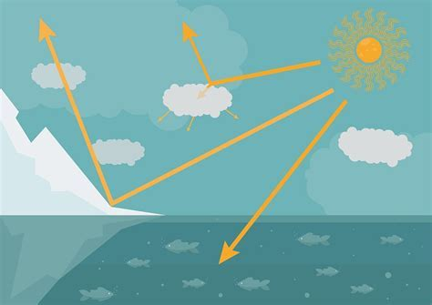

Action!
ALBEDO is a feedback-loop for the problem of global warming. As we learned, too much CO2 in the atmosphere increases the greenhouse effect and the earth will gradually overheat. Every person - even you as a pupil! - can do something about the greenhouse effect in everyday life and at home in the family. Research CO2 saving tips yourself!
https://www.zdf.de/kinder/logo/bilderserie-tipps-gegen-klimawandel-126.html
But it is also important that politicians make the right decisions so that less CO2 is released into the air, for example by closing down coal-fired power plants. In Germany, for example, this is not the case until the end of 2038. Many climate activists and scientists are in favor of an earlier closure of coal-fired power plants. Become politically active yourself and call on politicians to act!
https://kids.greenpeace.com/taxonomy/term/39?type=knowledge
https://a.plant-for-the-planet.org/de/ideas-and-tools
https://www.bund.net/bund-tipps/natur-erfahren/umweltbildung/kinder

