science@venture - fast track

If you undertake this energy adventure on the fast track, it will take you between 60 and 180 minutes nevertheless. Experimenting is the core of the science and energy@venture. It is more exciting, if you let the experiments and experiences be carried out in groups in a “science-circle”. However, to safe time, each group of the students explores only one scientific challenge!

UNIT 1 1
Scientific Experimenting and Documenting 1
Goal / Objectives 1
Learning outcomes 1
Groundwork 2
Step by step 2
Storytelling Intro 2
Read the “f.” manual 2
UNIT 2 3
Six Climate Experiments 3
Goal / Objectives 3
Learning-outcomes 3
Groundwork 3
Preparation 4
Step by step 4
Storytelling Intro and Repeat 4
Experience and Experimenting 4
Albedo Effect 4
Energy-use and electric current 5
Proper Insulation 5
Green mobility 5
Food & Carbon Dioxide 5
5 “rs” for better world 6
UNIT 3 6
Shared Knowledge and Good Intentions 6
Goal / Objectives 6
Learning-outcomes 6
Fast track 6
Preparation 7
Step by step 7
Constructive Journalism 7
Present Results 7
Letter to yourself 7
Mnemonic Climate Change 8

UNIT 1

Scientific Experimenting and Documenting

Goal / Objectives
- Understand the need for precise instructions through a sandwich-making example.
- Learn the balance between planning and action, and that over-planning can lead to frustration. Understand that failures are part of learning and nothing can go wrong with safe experiments.
- Learn to take preventive measures by watching presentations and following tips to improve work effectiveness.
Afterwards your students should be able to apply precise instructions in a practical scenario and to balance planning and action in a task. Finally they should “welcome” failures and apply preventive measures to improve work effectiveness.

Learning outcomes
- Apply Precise Instructions: Students will demonstrate following and applying precise instructions in a practical task, understanding the need for clear, specific directions to achieve effective outcomes, and extending this skill across various contexts.
- Balance Planning and Action: Students will understand and manage the balance between planning and executing, recognizing when to shift from one to the other and demonstrating adaptability and resilience when faced with unforeseen challenges.
- Embrace Failures and Implement Preventive Strategies: Students will learn to view failures as learning opportunities, embracing them to foster growth while effectively applying preventive measures and strategies to enhance productivity and task success.

Participants | Duration | Materials/Location
Number: Class or group 12-25 students.  Age: 14 + | 30 min | Projector, laptops, equipment for documentation and access to a school-cloud and media-platforms

Groundwork
In a video, children give their dad "precise" instructions to make a sandwich, but it goes wrong, causing frustration. Over-planning can kill joy and laughter from unexpected outcomes. So, dare to just "do it". All experiments are safe. To avoid failures, watch the class presentation first. Following the obvious tips will make your work effective. Please remind them to document all steps - already now! Here is a list of all materials and devices that are needed to carry out the experiments. Ask your headmaster to give access to a school-cloud or a different one to make sharing results and documentation - and story-telling easier.

Step by step

Step | Slide | Time | Instructions
1. | Storytelling Intro  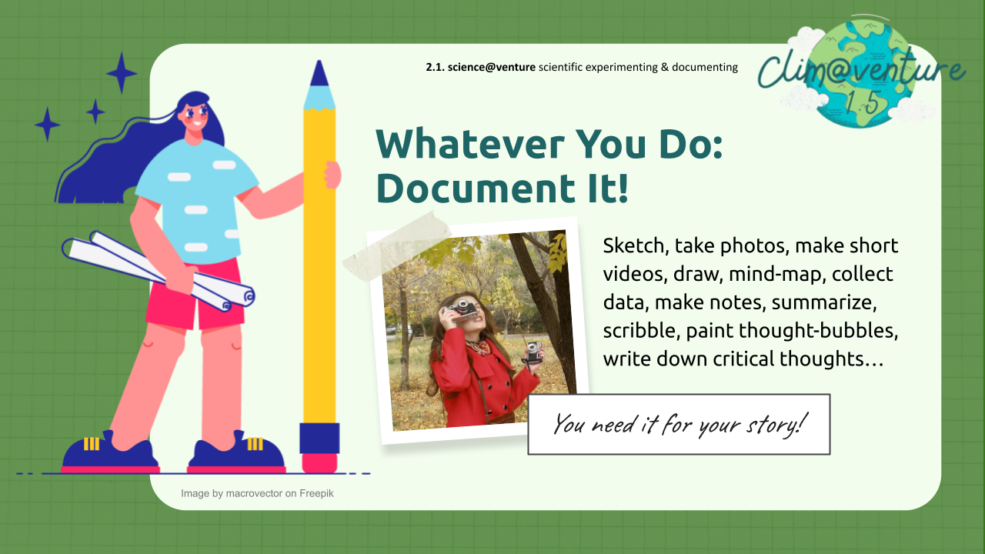 | 10’ | Remind your students to document everything they do, even if it's just scenes and impressions of an introduction! It's best if you choose a digital/video-savvy student for each unit. Remember to provide a platform where the image/video/sound material can be shared and selected by everyone for a story.
2. | Read the “f.” manual  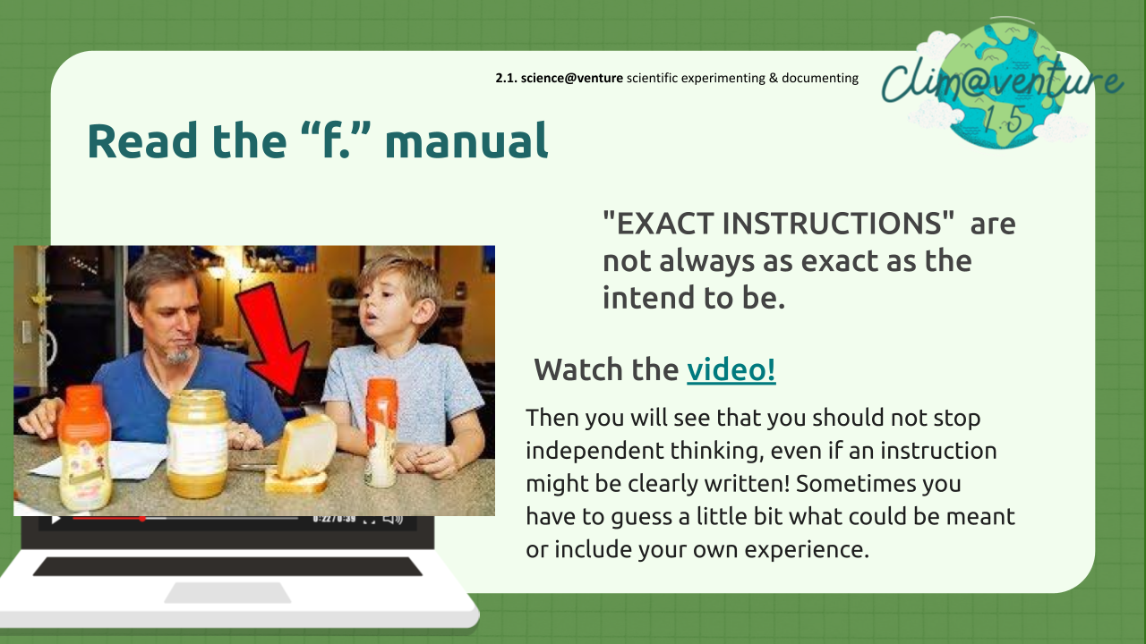 | 20’ | In the linked video, children’s precise instructions for a peanut butter sandwich go awry, causing frustration but also humour. Remember: Over-planning can stifle joy and laughter from unexpected outcomes. So, dare to let your students experiment. It’s all safe and nothing can truly go wrong. Give them more background to the importance of reading before acting!

UNIT 2

Six Climate Experiments

Goal / Objectives
With to carry out the same experiment?
- Do you decide which one or do you leave the choice to them?
- Should they choose different ones for small groups - work independently?

Material they need is explained in the instructions and a list at the end of this page. All material is available in your household, at school or can be bought with little money in the supermarket.different experiments and activities, your students will learn to better understand climate change today. They discover fields of impact of carbon-dioxide emissions.

You should decide:
- Do you want all of them

Learning-outcomes
- Document and Reflect on Learning Processes: Students will develop the ability to document their learning processes through various creative means such as sketching, photographing, video recording, and note-taking. They will form a documentation crew to consolidate and share these insights, enhancing their understanding and ability to communicate their findings effectively.
- Understand and Experiment with Climate-Relevant Concepts: Students will gain a comprehensive understanding of various climate-related topics, including mobility, energy consumption, insulation, and nutrition, through hands-on experiments and experiences. They will be able to articulate the significance of these concepts and their impact on the environment, demonstrating an awareness of the practical application of theoretical knowledge in real-world contexts.

Participants | Duration | Materials/Location
Number: groups in 2-4 students  Age: 14+ | 60 Minutes if the students carry out only 1 experiment | See list  Equipment for documenting and access to a cloud to share digital material

Groundwork
When students are tasked with bringing materials, there will certainly always be some who have "forgotten" them. You must decide whether to provoke this situation or to bring the necessary items from home yourself.😃

Preparation
Here is a list of all materials and devices that are needed to carry out the experiments.
Ask your headmaster to give access to a school-cloud or a different one to make sharing results and documentation - and story-telling easier.

Step by step

Step | Slide | Time | Instructions
1. | Storytelling Intro and Repeat | 10’ | Whatever step is ahead: Let your students document it: Sketch, take photos, make short videos, draw, mind-map, collect data, make notes, summarize, scribble, paint thought-bubbles, write down critical thoughts…  It's best to initiate from the beginning that a group of students forms a crew for public relations and documentation. They will need suitable equipment and the ability to share their digital materials (in a cloud).
2. | Experience and Experimenting  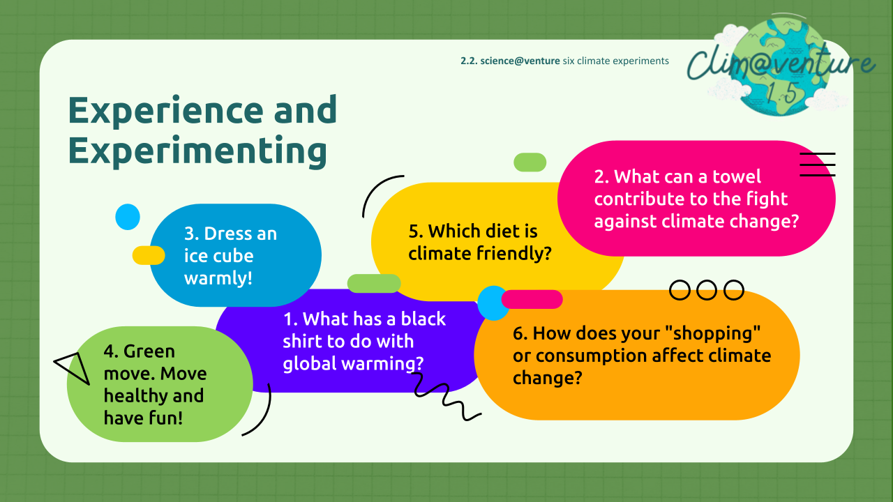 | 20’ | Talk to the students for an overview: In the experiments and actions we propose, we cover all possible fields of action in terms of climate relevance: mobility, electricity (consumption), heating (and insulation), nutrition, consumption, climate tipping points (albedo). In addition to providing learning opportunities for individuals and understanding the effects of individual actions, it is important to address options for action and control in political and societal terms.  Prepare and check material for experimenting and experience!
3. | Albedo Effect  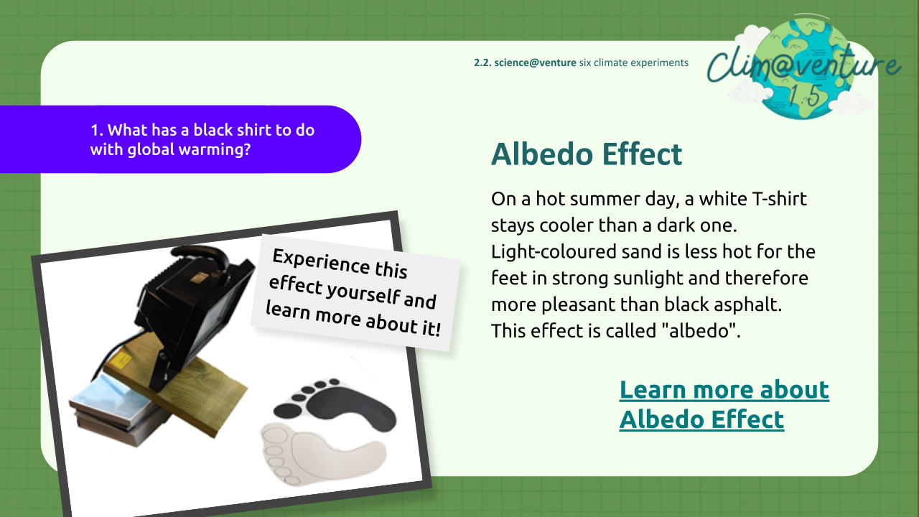 | 30’ | On a hot summer day, a white T-shirt stays cooler than a dark one. Light-coloured sand is less hot for the feet in strong sunlight and therefore more pleasant than black asphalt. This effect is called "albedo". Let your students explore this effect with some simple experiments!
4. | Energy-use and electric current  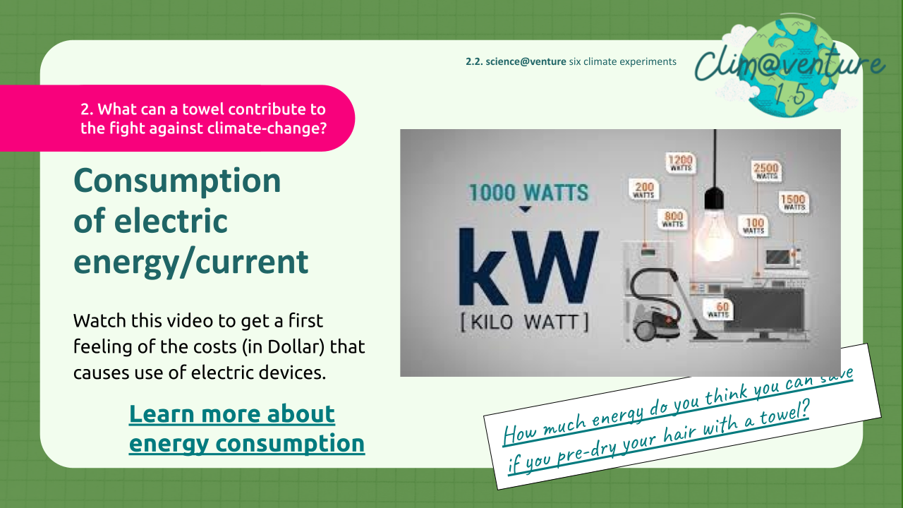 | 30’ | Let the students watch this video to get a first feeling of the costs (in Dollar) that causes use of electric devices.  Suggest the exercises and experiences, that are described in the worksheet.
5. | Proper Insulation  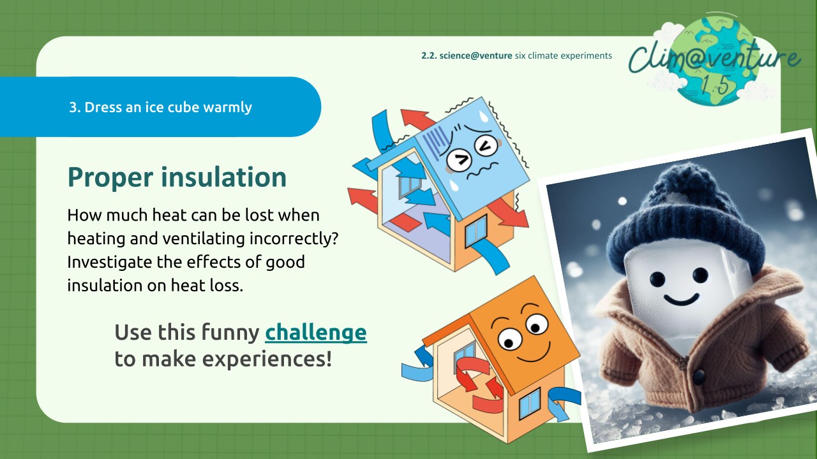 | 30’ | Discuss beforehand, then let the students carry out the experiment linked in the worksheet: How much heat can be lost when heating and ventilating incorrectly?  Have them investigate the effects of good insulation on heat loss and experience it in this mini "indoor adventure". Find solutions to obtain interesting results even when the sun isn't shining and the students don't have access to warm lighting."
6. | Green mobility  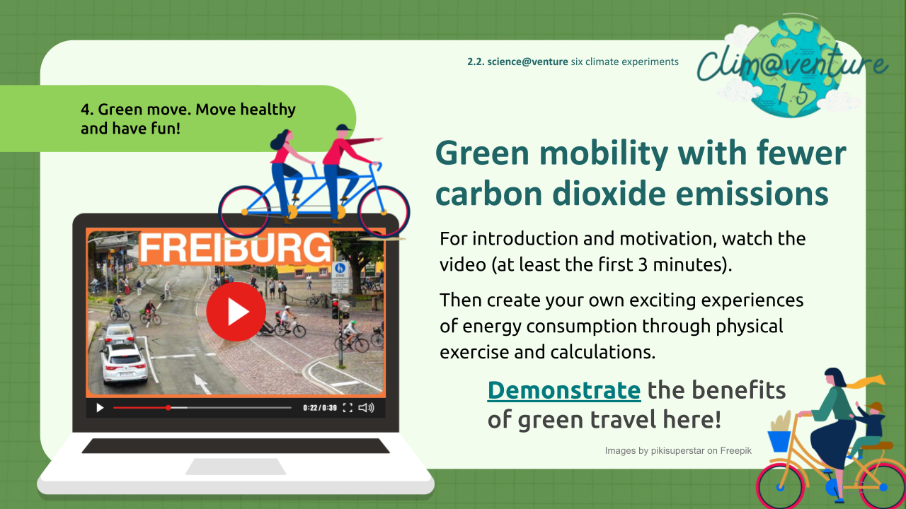 | 30’ | Explore with your students: Green mobility with fewer carbon dioxide emissions in their hometown, in cities in the neighbourhood, in cities where exchange-students might come from. For introduction and motivation, watch the video (at least the first 3 minutes) together.  Then create your own exciting experiences of energy consumption through physical exercise and calculations. The worksheet with background-information and instruction will help.
7. | Food & Carbon Dioxide  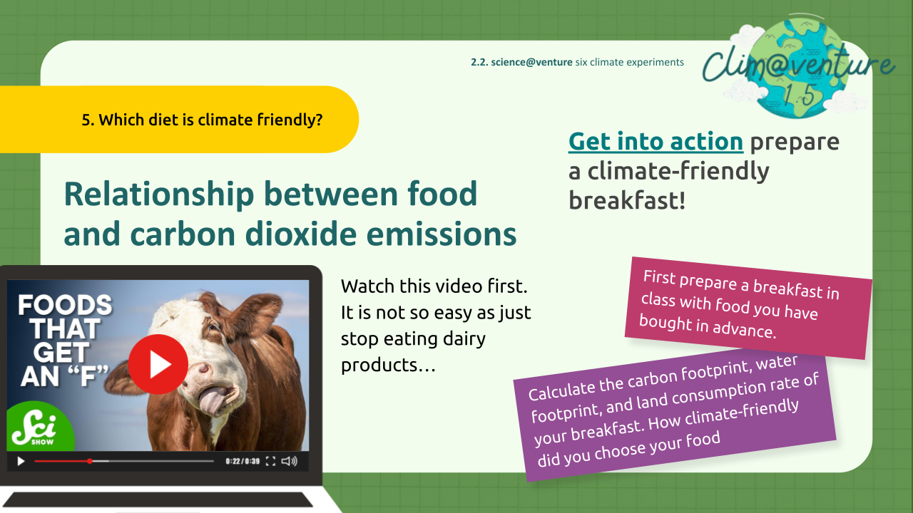 | 30’ | Explore together the relationship between food and carbon dioxide emissions: Prepare a breakfast in class with food, students have bought in advance. Let them calculate the carbon footprint, water footprint, and land consumption rate of your breakfast. How climate-friendly did they choose their food?  Get more information, background and detailed instruction for this action by using the worksheet.
8. | 5 “rs” for better world  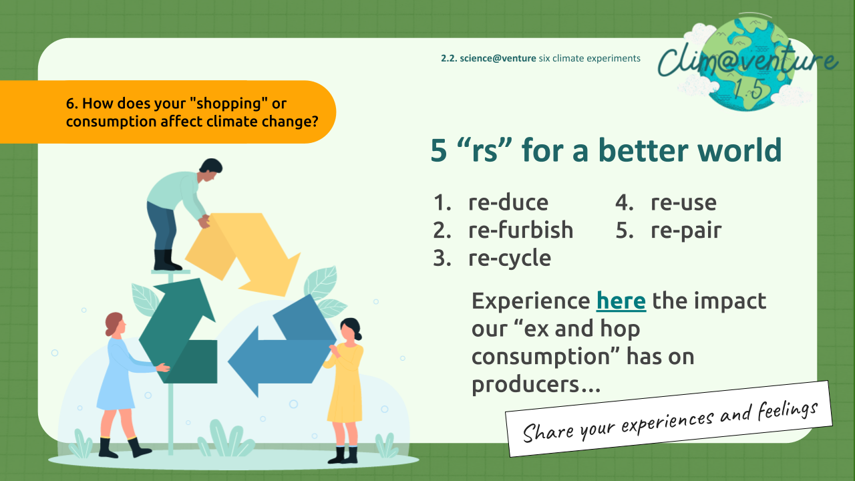 | 30’ | Let your students experience the impact of our 'ex and hop consumption' on producers. Take time for reflection and let them share their experiences and feelings, not only within their working group but also in class. Encourage a discussion about possible changes. Remind them of the 5 Rs - to create a better, more equal, and fair world! Ask them to follow the instructions step by step and not skip anything. Otherwise, they would not feel their personal responsibility for their lifestyle.

UNIT 3

Shared Knowledge and Good Intentions

Goal / Objectives
- Repetition about “constructive” journalism, knowledge and application of the principles of it
- Ability to present scientific results in a compelling and engaging manner.
- Learn to use well known tools for story-telling such as presenting, writing
- incite a discussion with class-mates and “call for action”
- Use the method of “letter-writing” for reflection and critical review
- Create a Mnemonic sentence about climate-change
- Create a big Show about your scientific@venture

Learning-outcomes
- Journalism Application: Students apply constructive journalism to present scientific content engagingly.
- Interactive Storytelling: Students effectively use various storytelling tools to provoke discussions and actions.
- Climate Communication: Students creatively convey climate science through mnemonics and organized presentations.

Participants | Duration | Materials/Location
Number: 2-4 per group  Age: 14 + | 60 | The required material depends on the number of steps and the extent of the storytelling, which concludes this module.

Fast track
If you cannot spare much time, the presentation of the results and the storytelling will inevitably have to be brief. You can assign as homework that the students write creative “stories” about their experimental experiences. Leave it up to them to choose the format in which the story is told: digital, as a painted summary, as audio, etc. Take the steps below as proposals.

Preparation
Depending on the extent of the planned presentation and way of story-telling you find our estimation for the time which is required. See: step by step!

Step by step

Step | Slide | Time | Instructions
1. | Constructive Journalism  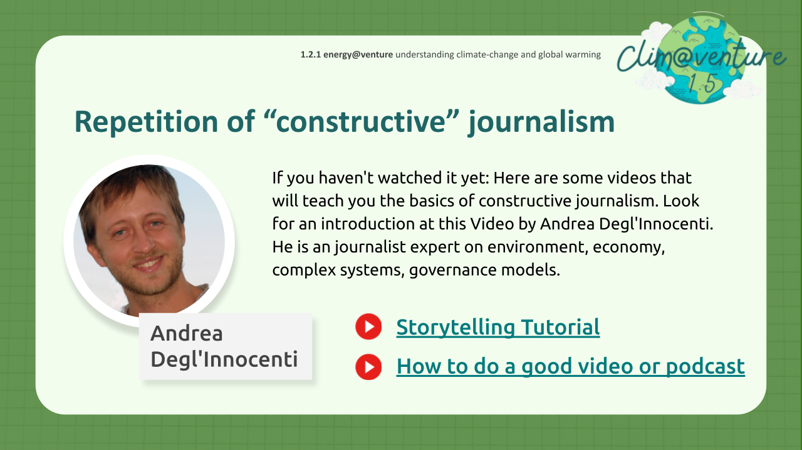 | 10’ | If your students haven't watched it yet: Here are some videos that will teach them the basics of constructive journalism. Let them look for an introduction at this Video by Andrea Degl'Innocenti. He is a journalist expert on environment, economy, complex systems, governance models. Let your students watch (maybe again?!) the Storytelling-Tutorial  How to do a good podcast or video - for science-purpose or just to repeat principles about good story-telling.
2. | Present Results  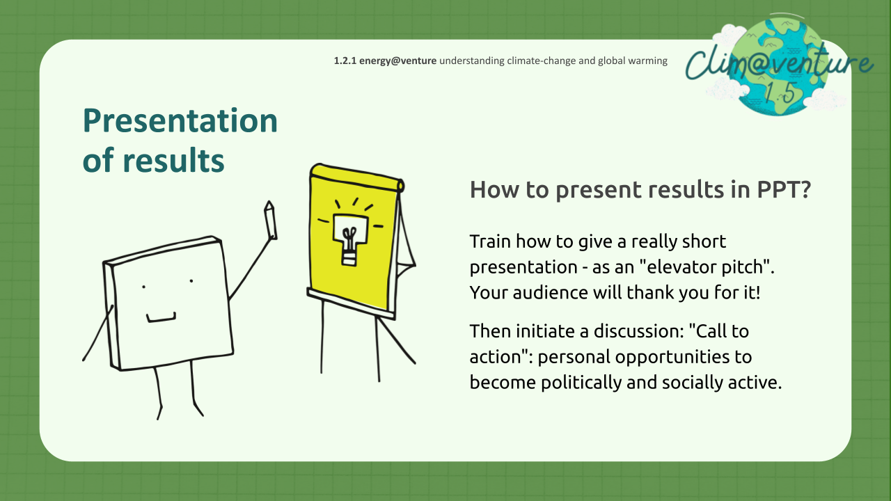 | 20’ | Train how to give a really short presentation - as an "elevator pitch". Your audience will thank you for it! Then initiate a discussion: "Call to action": personal opportunities to become politically and socially active.  Find more information to this step in the worksheet, which also includes background-information and useful “ingredients” to present a result/a story in a catch way!
3. | Letter to yourself  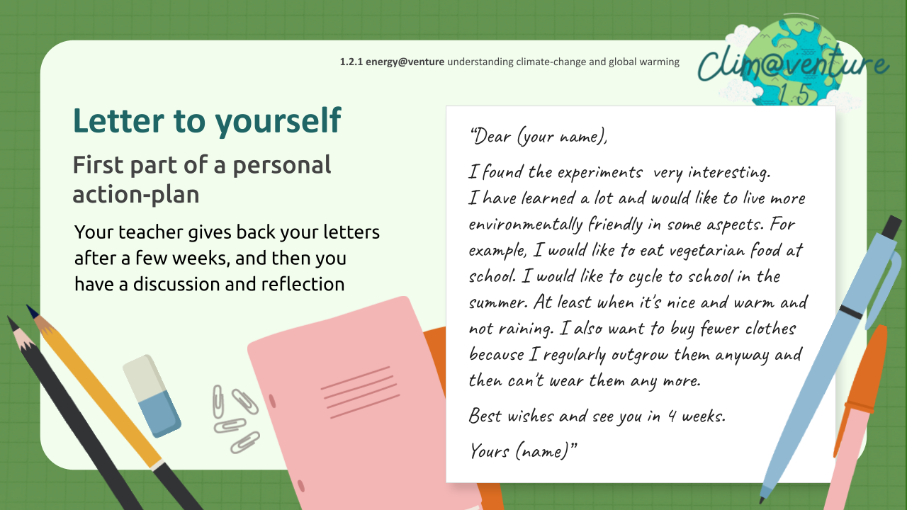 | 15’ | Assure your students: They do not have to helplessly watch as the Earth - their future - is destroyed! Let them make concrete plans for what they can and will do about it! Let them write a letter to yourself summarising their good intentions and the way they want to achieve them. Make sure, that they work quietly for themselves alone. This is a private thing!
4. | Mnemonic Climate Change  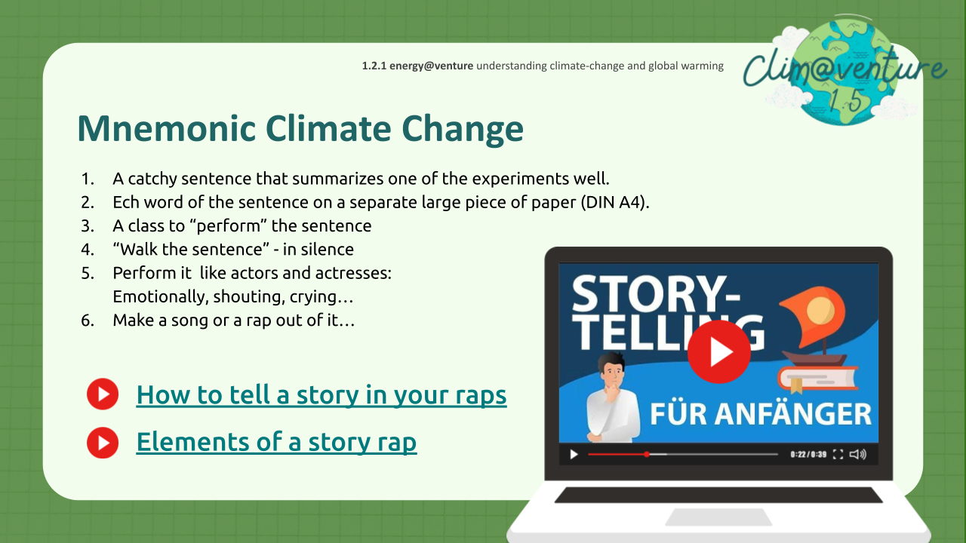 | 15’ | Teachers, engage students with storytelling through a mnemonic sentence activity - which is aimed for younger students in your school. Prepare word cards and guide students in arranging the sentence. Explore various delivery methods for impact, such as posters or songs. Your aim is to effectively disseminate knowledge. Gain inspiration from the "Storytelling" video and an instruction on how to rap a content.

