energy@venture - fast track

If you undertake this energy adventure, it will take you between 120 and 180 minutes. The most extensive part is 'storytelling' after the session.

UNIT 1 1
Reflections on the climate crisis, energy and CO2 1
Goal / Objectives 1
Learning-outcomes 1
Step by step 2
Discussion 2
UNIT 2 2
Understanding climate change and global warming 2
Goal / Objectives 2
Learning-outcomes 3
Preparation 3
Step by step 3
Sketch, take photos 3
Jump 4
UNIT 3 4
What Is Scientific Storytelling? 4
Goal / Objectives 4
Learning-outcomes 4
Groundwork 5
Step by step 6
Storytelling Intro 6
Create a story 6

UNIT 1

Reflections on the climate crisis, energy and CO2

Goal / Objectives
- Our goal is to create an environment for students to discuss ideas about the world they want to live in.
- We educate on climate threats, introducing a living conditions simulation and exposing artistic climate activism like storytelling.
- We aim to develop skills in differentiating facts, tackling fake news, and engaging in debates with serious arguments.

Learning-outcomes

Students will
- be able to articulate their visions for a sustainable future and critically discuss various ideas on this topic.
- gain an understanding of climate threats and the role of artistic activism in raising awareness, through participation in simulations and analysis of storytelling.
- develop critical thinking skills to differentiate factual information from fake news and effectively engage in debates with logical arguments.

These outcomes are designed to ensure that students not only acquire knowledge about climate threats and activism but also develop essential skills in critical thinking, communication, and information literacy that are crucial for informed citizenship and effective advocacy.

Participants | Duration | Materials/Location
Number: 3-99 (partially in groups of 2-5)  Age: 14+ | 15-30 min | Projector, smart-phones, access to the internet (for each student’s device), headphones for students.

Step by step

Step | Slide | Time | Instructions
1. | Discussion  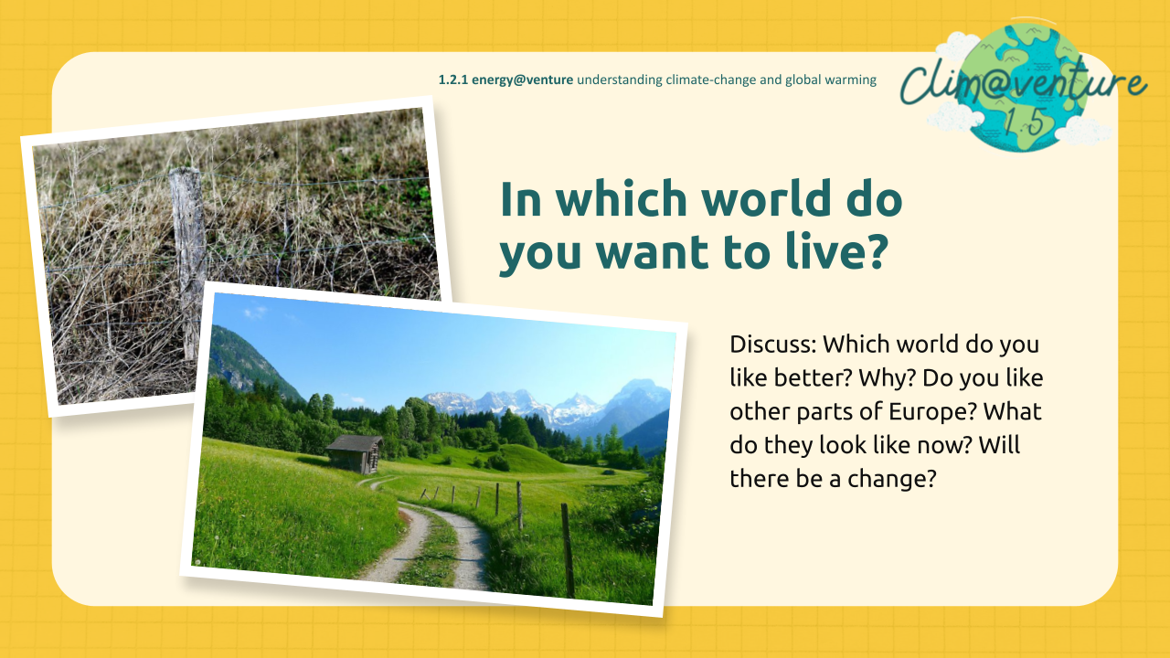 | 15-30’ | Ask your students: In which world do you want to live? Think of our world, of crisis, threats - and solutions. Also think about the SDGs and what you have learned about it. Think for a few minutes for yourself. Then compare the first two pictures in the presentation.

UNIT 2

Understanding climate change and global warming

Goal / Objectives
- You will learn how to experience energy with your body, how to regenerate energy and where our energy comes from
- Discover the characteristics of gases and their impact, including a practical application in extinguishing a tea light.
- Understand the greenhouse effect and the the impact of human activities on it

Learning-outcomes

Students will
- demonstrate an understanding of bodily energy, its regeneration processes, and its sources through practical experiences and reflections.
- identify and explain the properties of gases, demonstrating their understanding through a practical experiment that involves using a gas to extinguish a tea light.
- explain the greenhouse effect, articulate the impact of human activities on it, and discuss potential mitigation strategies based on scientific principles.

Participants | Duration | Materials/Location
Number: 3-99 (partially in groups of 2-5)  Age: 14+ | 60 min | Projector, smart-phones, access to the internet, whiteboard or paper for wordcards DIN A4, thick pens  You can use step 1 as an energizer outdoor!

Preparation
Ask your students to bring into class, if you want them to experiment in pairs for themselves:
Warning: Make students with long hair tie their hair!
- A tea light + matches/lighter
- An empty, transparent bottle with cap
- One teaspoon of baking soda, citric acid or vinegar and some water
- Smartphone-timer

Step by step

Step | Slide | Time | Instructions
1. | Sketch, take photos  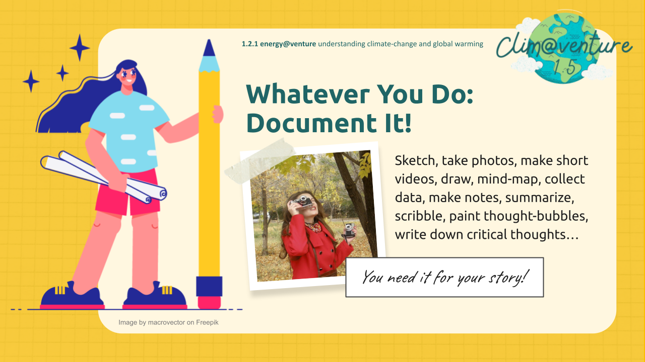 | 20’ | Remind your students in order to collect material for documenting and story-telling:  Sketch, take photos, make short videos, draw, mind-map, collect data, make notes, summarise, scribble, paint thought-bubbles, write down critical thoughts…
2. | Jump  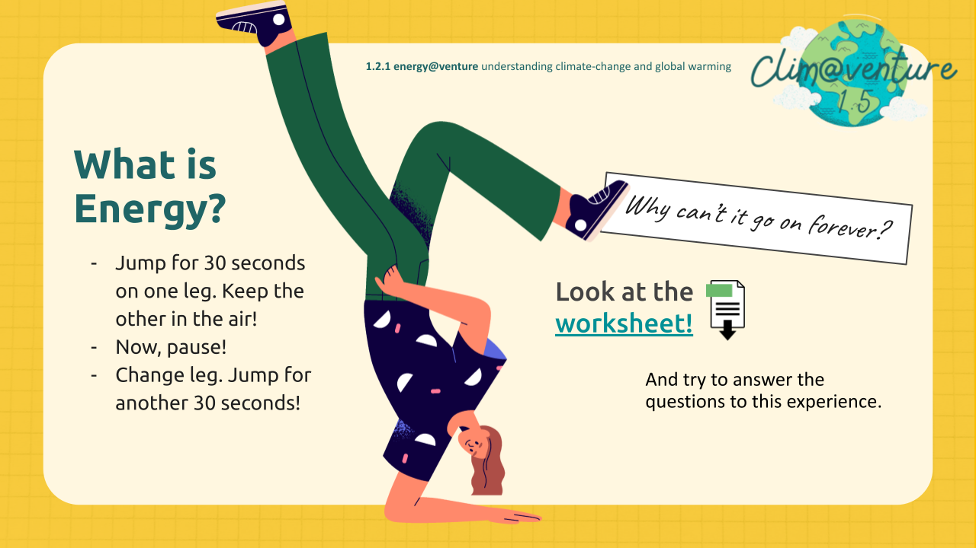 | 15’ | Motivate your students and tell them:  - Jump for 30 seconds on one leg  - Keep the other in the air!  - Now, pause!  - Change leg  - Jump for another 30 seconds!  Finally discuss: Why can’t this go on forever? Let them use the Worksheet to find answers.

3. | Make CO2 visible  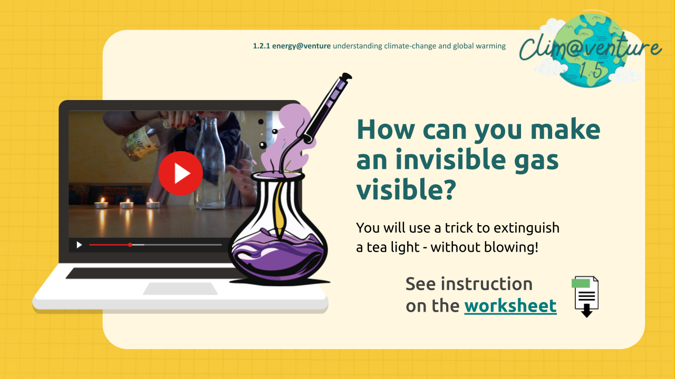 | 25’ | How can you make an invisible gas visible? Give the worksheet with instructions to your students. Let them explore the power of the invisible gas CO2. They should watch the video first for instruction. Stop the video before the explanation. Let them carry out the experiment , find out the explanation and the connection to climate-change and global warming with the worksheet.
4. | Why is it warm in a greenhouse?  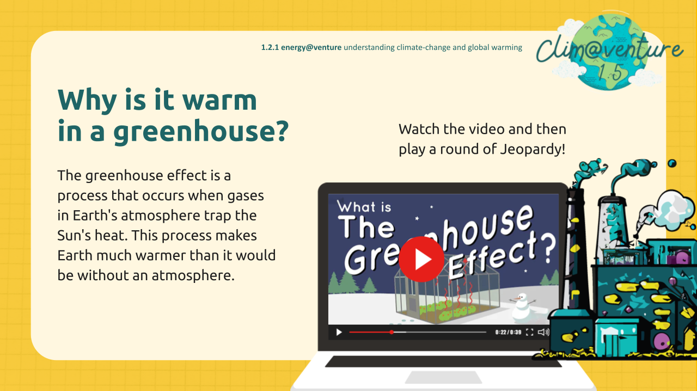 | 15’ | Let the students find out more about the natural and the human-made greenhouse effect and the consequences.

UNIT 3

What Is Scientific Storytelling?

Goal / Objectives
Students will
- Identify the importance of conveying topics that don’t get enough attention
- Identify such topics and how to convey them through gripping stories.
- Understand the impact of climate change and sustainability on a personal level
- Take action and make a difference through your actions
- Develop skills to create engaging video stories and learn about the structure of exciting stories with various examples and how to tell them with different media
- Document their stories with cell phones, sketch pads, word cards, etc
- Learn how to create engaging video content with different tools.

Learning-outcomes
Students will
- be able to recognize underrepresented topics and effectively communicate them through compelling narratives, demonstrating this ability by creating engaging stories that highlight these issues.
- understand the personal relevance of climate change and sustainability, formulating and implementing a plan of action to address these issues in their own lives and communities.
- acquire the skills to craft engaging video stories, using a variety of tools and media (such as cell phones, sketch pads, word cards) to document and share their narratives, illustrating their knowledge of story structure and content creation techniques

Participants | Duration | Materials/Location
Number: 3-99 (partially in groups of 2-5)  Age: 14+ | 80 min | Smartphones or laptops where you can download useful apps to create digital stories. Paper, poster, colors to have an exhibition or gallery-walk about results.

Groundwork
There are many ways of telling stories! Many are probably familiar to you. Let the students decide the format of their story and let them watch our selected instruction, to get best results!

Step by step

Step | Slide | Time | Instructions
1. | Storytelling Intro  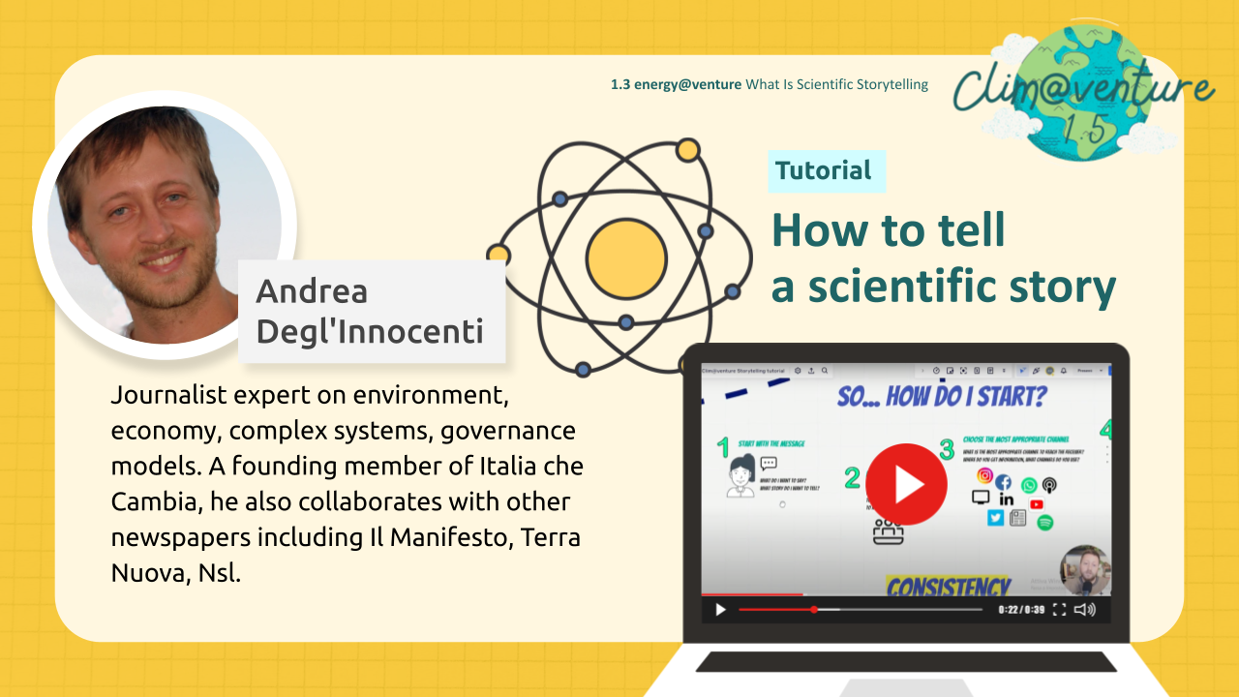 | 20’ | Let your students see as an example: A Journalist expert on environment, economy explains complex systems and governance models.  Let them research about the aim of the network of Italia che Cambia that he founded.
6. | Create a story  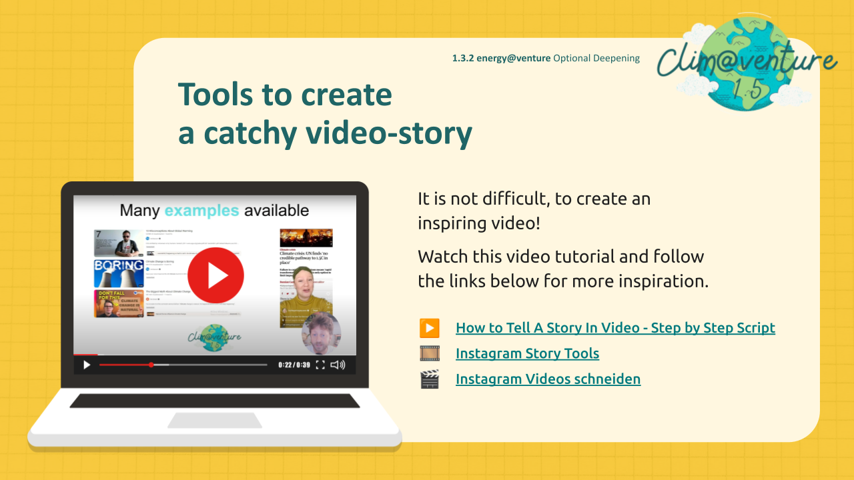 | 60’ | Give time to your students to produce a simple video about either the energy-consumption, CO2 or the greenhouse-effect. Hopefully they have documented their work!? Initiate exchange with students in other schools or schools abroad to let the students experience more reach and more impact. Some examples from other students may be a good motivation in this folder.

