journalist@venture
fast track

How to become a SDG reporter

Setting the Stage

Goal / Objectives
- You will learn how to become an SDG reporter and acquire the tools and skills needed:
- You will learn how to use effective storytelling, film effectively, and create a story that truly engages your audience.
- After this module, you will be prepared to go into the field and discover interesting stories of change in your surroundings.

Participants | Duration | Materials/Location
Number: 3-99 (partially in groups of 2-5)  Age: 14+ | 60 min - fast track | Projector, smart-phones or PC/TV to play the Videos, access to the internet,

Preparation
- No preparation

Step by step

Step | Slide | Time | Instructions
1. | How to become a SDG reporter  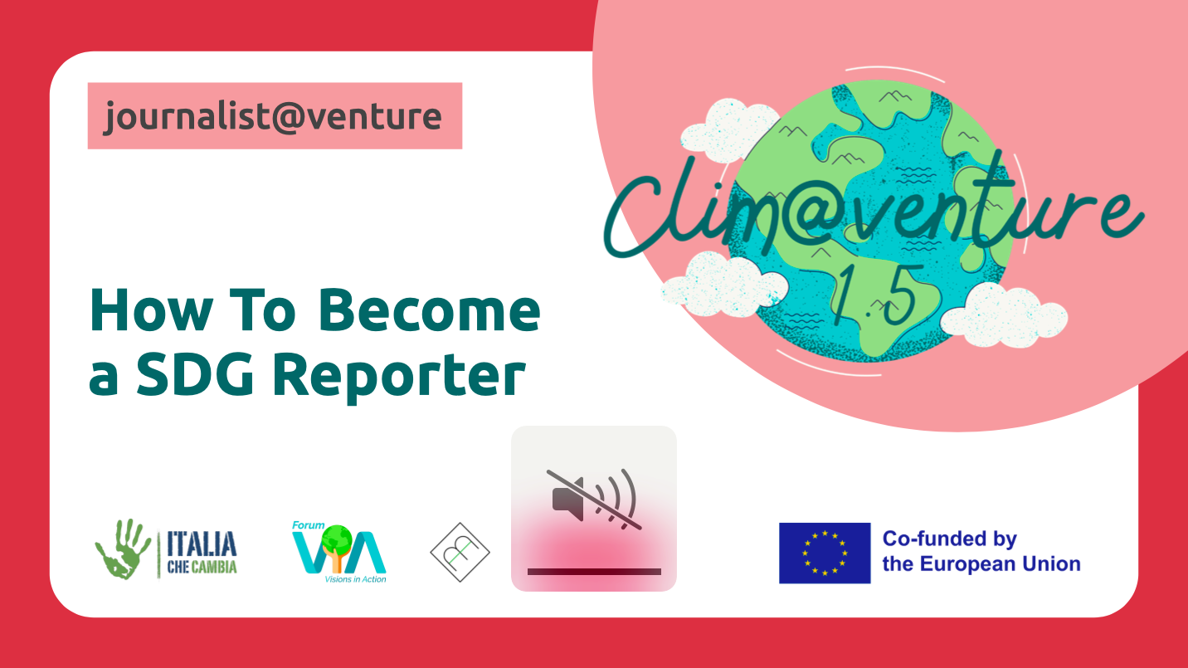 | 2´ | Ask your students what they associate with a SDG reporter. Remind your students what it means to become a SDG reporter. SDG=Sustainable development goals =A reporter for sustainability. Become a SDG reporter, amplify the local changemakers in your community and share your own story!
2. | Skills of a SDG reporter  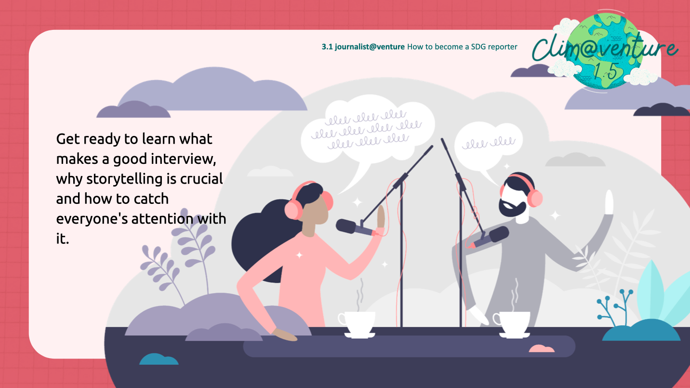 | 1’ | Inform your student that the fast track of this module will focus on the following skills of a SDG reporter:  - effective storytelling  - conducting good interviews  - following up the interview and prepare a video or podcast to share the outcomes  Give your students a little heads up: This module is very technical and a lot of information to take in! Next module will be the opposite, so stay patient!
3. | Practice what you learn!  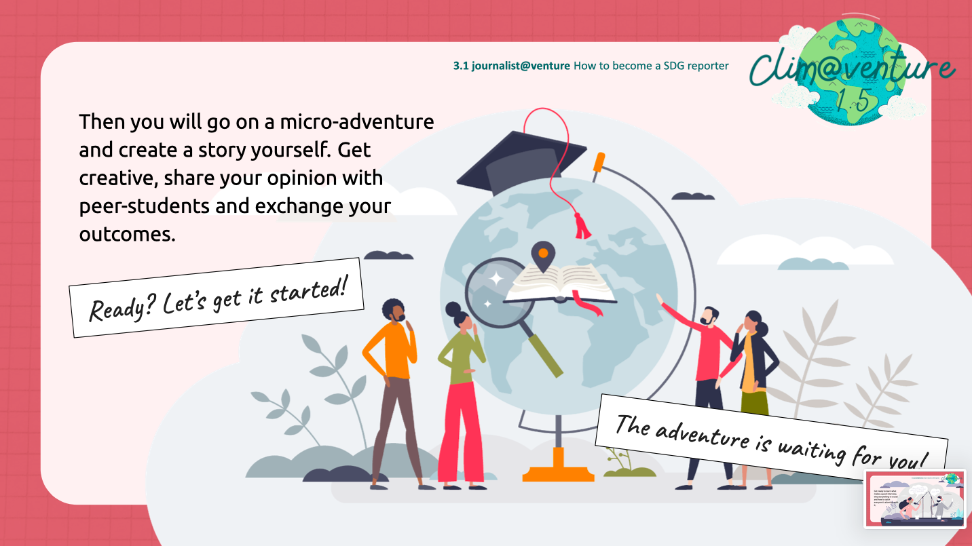 | 2’ | Get your students excited to learn everything what they will need for the next module, their mico-adventure: when they finally approach their initiatives of their interest and choice and put everything into practice: interviewing, storytelling, creating a video/podcast! And also share it with their peers!
4. | The Art of Storytelling  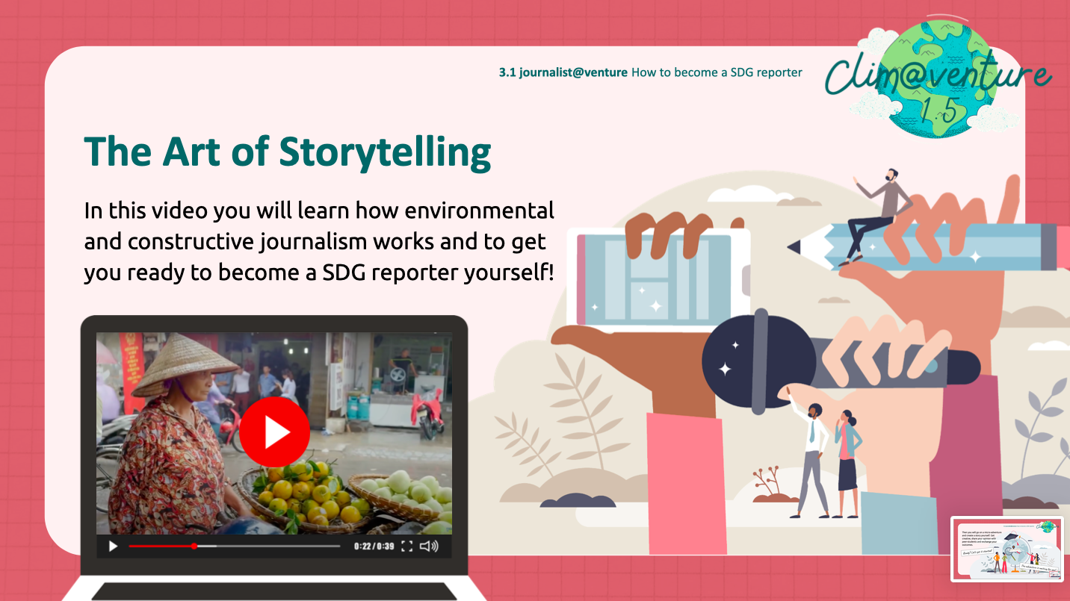 | 15’ | Watch the Video as a source of information for the next module and tell your students to make notes:  The Art of Storytelling
5. | One powerful example  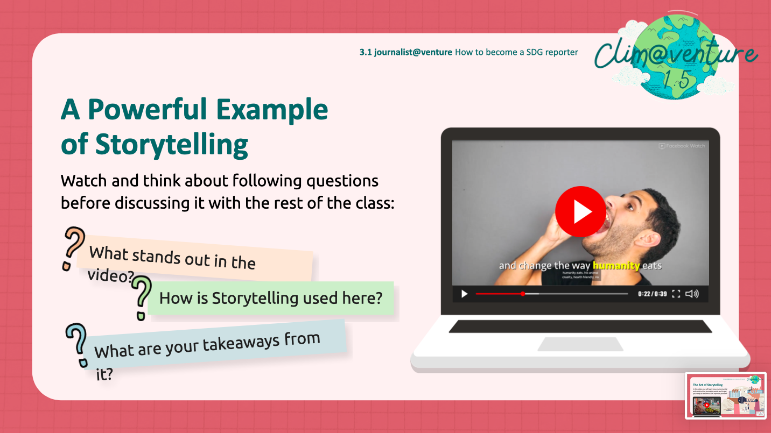 | 10’ | Watch the Video: Example of powerful Storytelling  And ask your students reflect upon three questions in small groups for 5 minutes:  1. What stands out in the video?  2. How is storytelling used here?  3. What are your takeaways from it?  At the end, offer everyone the possibility to share their learnings in the class.
6.  optional | How to conduct a Good Interview  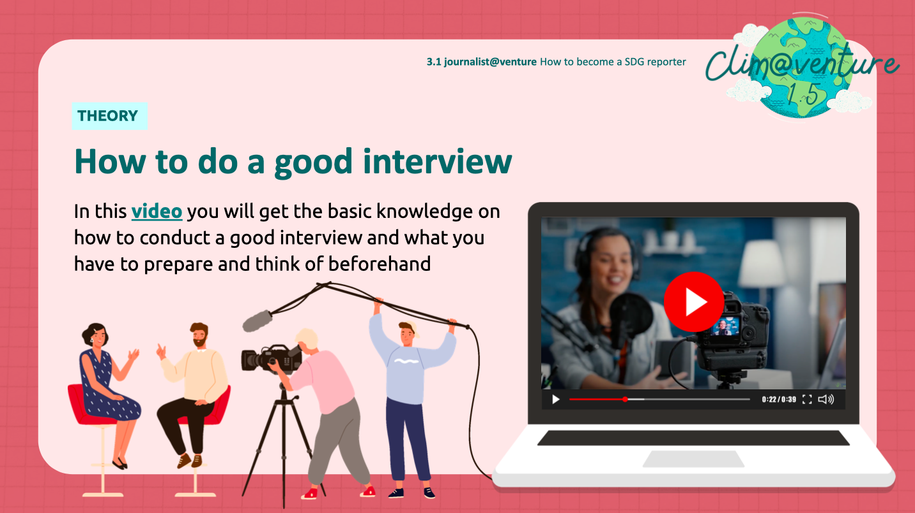 | 15’ | Watch the Video as a source of information for the next module and tell your students to make notes:  How to Interview
7. | How to produce a Video & Podcast  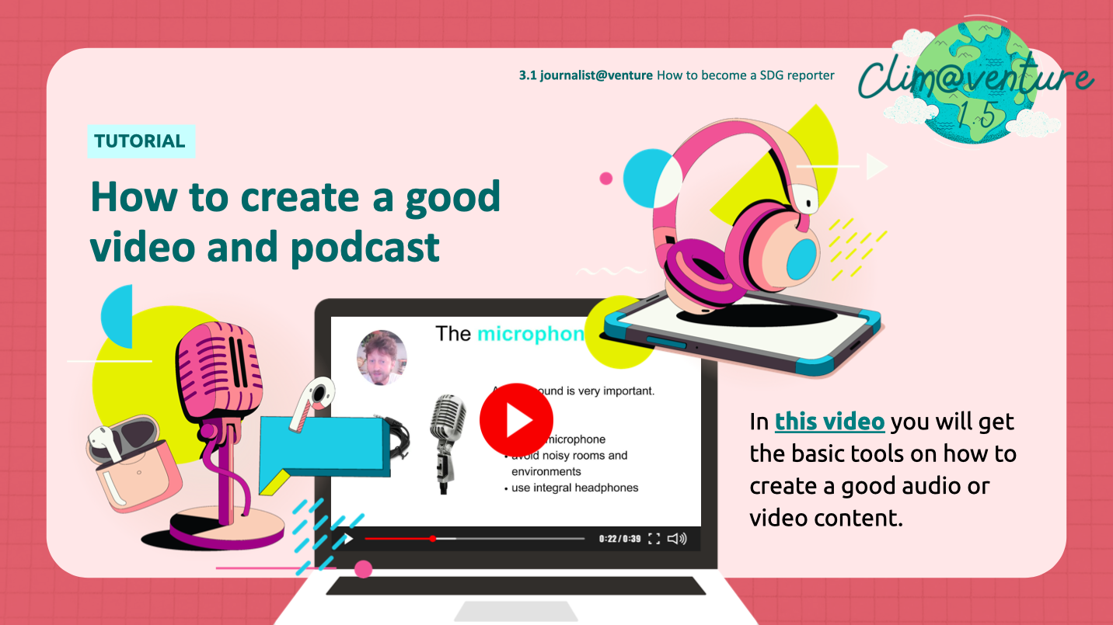 | 15’ | Watch this technical video together, how to produce a video or podcast:  https://www.youtube.com/watch?v=wvd2zN5STic  This is a video with the BASIC skills for video/podcast production. Remind your students to use all their experience and creativity, and to help each other out. Maybe there is an expert in your class? Let them share their skills with the whole class!

